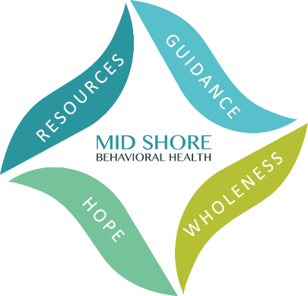

Mid Shore Behavioral Health, Inc.
2024 Caliber Awards – Friday, May 17
Achieving Excellence in Public Behavioral Health

Nomination Form
Adult and Older Adult Behavioral Health Advocacy Award
Nominations are due by Friday March 8, 2024.

The Adult and Older Adult Services Workgroup Award recognizes an individual that exemplifies extraordinary efforts as an advocate for adults and older adults with behavioral health needs in our community. Their endeavors show continued collaboration with consumers of the Public Behavioral Health System, their natural supports, providers, and community entities. Through creative problem solving and/or developing partnerships in the mid-shore, this individual works towards bridging the gaps within behavioral health services to address health disparities. They share their knowledge of and passion for behavioral health advocacy with others. The nominee must be a volunteer or provider of behavioral health services (mental health and/or substance use) within the mid-shore region.
Nominated By: *

Full Name:

Organization (if relevant):

Email Address:
Phone Number:

Person Nominated: *
Full Name:

Organization (if relevant):
Email Address:

Phone Number:
*The nomination may not be accepted without complete names and contact information for both the nominee and the nominator.
Please provide the reason for the nomination below. The reason must match the description of the award category above and be as detailed as possible. Please no more than one page.

Completed Nominations can be submitted by fax, email, or snail mail:

- Fax to 410-770-4809
- Email to kmoran@midshorebehavioralhealth.org;
- Postal mail to:
ATTN: Kelley Moran, Administrative Director
Mid Shore Behavioral Health, Inc.
28578 Mary’s Court, Suite 1
Easton, MD 21601

Nominations are due by Friday March 8, 2024.

