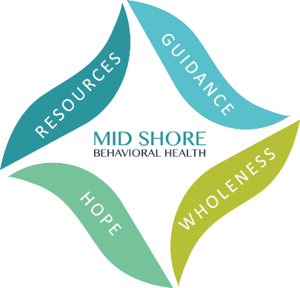
Mid Shore Behavioral Health, Inc.
2024 Caliber Awards – Friday, May 17
Achieving Excellence in Public Behavioral Health

Nomination Form
Nominations are due by Friday March 8, 2024.
Diversity, Equity, & Inclusion Award
The Diversity, Equity, and Inclusion (DEI) Champion award recognizes an individual, organization, or program that demonstrates commitment to, and passion for, full and meaningful incorporation of the principles of DEI. The DEI Champion award recipient may demonstrate routine advocacy for policy, program, and procedural (system) changes resulting in experience of dignity, equity, inclusion, and access for all, or may demonstrate leadership in community work, raising awareness and effecting change among community members. Whether the award recipient is involved in systems change, or community work, or both, please include a description of intended equitable outcomes and assessment practices.
Nominated By: *

Full Name:

Organization (if relevant):

Email Address:
Phone Number:

Person Nominated: *
Full Name:

Organization (if relevant):
Email Address:

Phone Number:
*The nomination may not be accepted without complete names and contact information for both the nominee and the nominator.

Please provide the reason for the nomination below. The reason must match the description of the award category above and be as detailed as possible. Please no more than one page.

Completed Nominations can be submitted by fax, email, or snail mail:

- Fax to 410-770-4809
- Email to kmoran@midshorebehavioralhealth.org;
- Postal mail to:
ATTN: Kelley Moran, Administrative Director
Mid Shore Behavioral Health, Inc.
28578 Mary’s Court, Suite 1
Easton, MD 21601

Nominations are due by Friday March 8, 2024.

