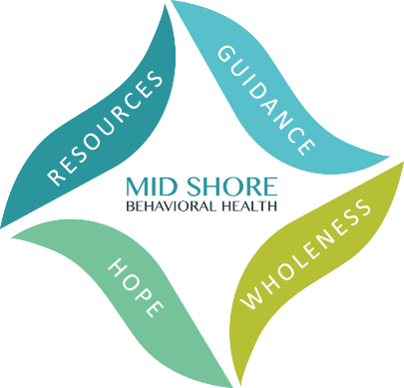

Mid Shore Behavioral Health, Inc.
2024 Caliber Awards – Friday, May 17
Achieving Excellence in Public Behavioral Health

Nomination Form
Nominations are due by Friday March 8, 2024.

Effective Programming
This award recognizes programs which are effective in improving the provision of behavioral health services for residents in the mid-shore region. Nominees will have demonstrated effective collaboration with consumers, family members, providers, and community leaders, using creative and cost-effective methods.
Nominated By: *

Full Name:

Organization (if relevant):

Email Address:
Phone Number:

Person Nominated: *
Full Name:

Organization (if relevant):
Email Address:

Phone Number:
*The nomination may not be accepted without complete names and contact information for both the nominee and the nominator.

Please provide the reason for the nomination below. The reason must match the description of the award category above and be as detailed as possible. Please no more than one page.

Completed Nominations can be submitted by fax, email, or snail mail:

- Fax to 410-770-4809
- Email to kmoran@midshorebehavioralhealth.org;
- Postal mail to:
ATTN: Kelley Moran, Administrative Director
Mid Shore Behavioral Health, Inc.
28578 Mary’s Court, Suite 1
Easton, MD 21601

Nominations are due by Friday March 8, 2024.

