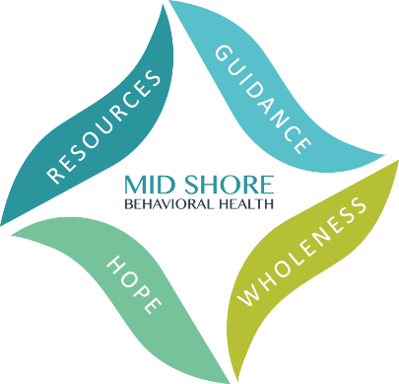
Mid Shore Behavioral Health, Inc.
2024 Caliber Awards – Friday, May 17
Achieving Excellence in Public Behavioral Health

Nomination Form
Nominations are due by Friday March 8, 2024.
Mary Beth Brennaman
This award recognizes an outstanding individual who demonstrates an unconditional commitment to, and passion for, the mission and vision of his or her organization. This individual brings sincere compassion to the population served, and humor, generosity, spirit, and an overall outstanding attitude to the workplace. The individual eligible for the Mary Beth Brennaman Award can be any person in an agency who demonstrates an exceptionally positive attitude and support for their team, and consumers served.

Nominated By: *

Full Name:

Organization (if relevant):

Email Address:
Phone Number:

Person Nominated: *
Full Name:

Organization (if relevant):
Email Address:

Phone Number:
*The nomination may not be accepted without complete names and contact information for both the nominee and the nominator.

Please provide the reason for the nomination below. The reason must match the description of the award category above and be as detailed as possible. Please no more than one page.

Completed Nominations can be submitted by fax, email, or snail mail:

- Fax to 410-770-4809
- Email to kmoran@midshorebehavioralhealth.org;
- Postal mail to:
ATTN: Kelley Moran, Administrative Director
Mid Shore Behavioral Health, Inc.
28578 Mary’s Court, Suite 1
Easton, MD 21601

Nominations are due by Friday March 8, 2024.

