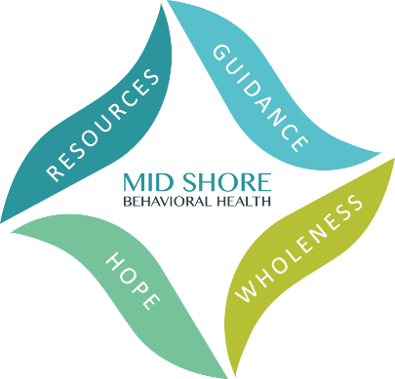

Mid Shore Behavioral Health, Inc.
2024 Caliber Awards – Friday, May 17
Achieving Excellence in Public Behavioral Health

Nomination Form
Nominations are due by Friday March 8, 2024.

This award is to recognize an individual who has shown exemplary dedication to our group’s mission of ending homelessness in the mid-shore region. This individual is committed to developing relationships, collaborating with community partners, and connecting individuals and families to quality services, to foster resiliency and growth. This individual is a fierce and knowledgeable advocate for those experiencing homelessness in our communities and works diligently to improve service delivery across the continuum.

Nominated By: *

Full Name:

Organization (if relevant):

Email Address:
Phone Number:

Person Nominated: *
Full Name:

Organization (if relevant):
Email Address:

Phone Number:
*The nomination may not be accepted without complete names and contact information for both the nominee and the nominator.

Please provide the reason for the nomination below. The reason must match the description of the award category above and be as detailed as possible. Please no more than one page.

Completed Nominations can be submitted by fax, email, or snail mail:

- Fax to 410-770-4809
- Email to kmoran@midshorebehavioralhealth.org;
- Postal mail to:
ATTN: Kelley Moran, Administrative Director
Mid Shore Behavioral Health, Inc.
28578 Mary’s Court, Suite 1
Easton, MD 21601

Nominations are due by Friday March 8, 2024.

