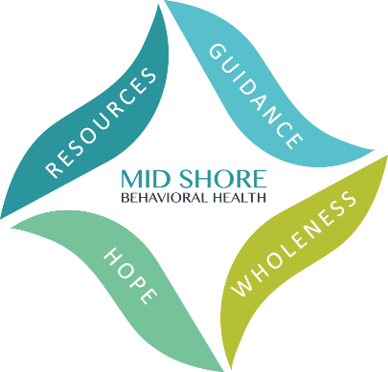

Mid Shore Behavioral Health, Inc.
2024 Caliber Awards – Friday, May 17
Achieving Excellence in Public Behavioral Health

Nomination Form
Nominations are due by Friday March 8, 2024.
Special Recognition Categories
Choose one below:
Deaf and Hard of Hearing | Consumer Choice | Trauma
Latino Population | Behavioral Health Integration | Advocacy
Volunteers | Peer Support | Prevention
Veterans | Emergency/Crisis Services | Leadership
Employment | Education | Defeating Stigma
Unsung Hero | Substance Use | Suicide Prevention
Wellness & Recovery

Nominated By: *

Full Name:

Organization (if relevant):

Email Address:
Phone Number:

Person Nominated: *
Full Name:

Organization (if relevant):
Email Address:

Phone Number:
*The nomination may not be accepted without complete names and contact information for both the nominee and the nominator.
Please provide the reason for the nomination below. The reason must match the description of the award category above and be as detailed as possible. Please no more than one page.

Completed Nominations can be submitted by fax, email, or snail mail:

- Fax to 410-770-4809
- Email to kmoran@midshorebehavioralhealth.org;
- Postal mail to:
ATTN: Kelley Moran, Administrative Director
Mid Shore Behavioral Health, Inc.
28578 Mary’s Court, Suite 1
Easton, MD 21601

Nominations are due by Friday March 8, 2024.

